**BATCH 1**

**The Smart Lighting System**

**AIM:** To Study the Different cases of Smart Lighting System

**OBJECTIVE:**

**1. Energy Efficiency:** Smart lighting systems aim to reduce energy consumption by automatically adjusting brightness levels, turning off lights when not needed, and utilizing energy-efficient LED bulbs.

**2. Customization and Control:** Users can customize lighting settings according to their preferences, including brightness, colour temperature, and scheduling. Remote control capabilities enable users to adjust lighting from anywhere using mobile devices or voice commands.

**3. Enhanced Comfort and Convenience:** Smart lighting systems provide convenience by automating lighting based on occupancy sensors, time schedules, or environmental conditions. They can create personalized lighting scenes for various activities like reading, relaxing, or entertaining.

**4. Integration with Other Smart Systems:** Integration with other smart home devices and systems allows for seamless automation and coordination. For example, lights can be synchronized with security cameras, thermostats, or motion sensors for enhanced functionality and security.

**5. Data Collection and Analysis:** Smart lighting systems can gather data on energy usage, occupancy patterns, and environmental conditions. This data can be analysed to optimize energy efficiency further, improve user experience, and even contribute to building management systems.

**6. Sustainability:** By reducing energy consumption and promoting efficient lighting practices, smart lighting systems contribute to sustainability efforts and environmental conservation.

**7. Enhanced Safety and Security:** Smart lighting can enhance safety by automatically illuminating pathways or entry points when motion is detected. It can also simulate occupancy when users are away to deter intruders.

**CASE STUDIES :**

**CASE STUDY 1 :**

**Case Study 1:** Smart Lighting System Implementation in Retail Store

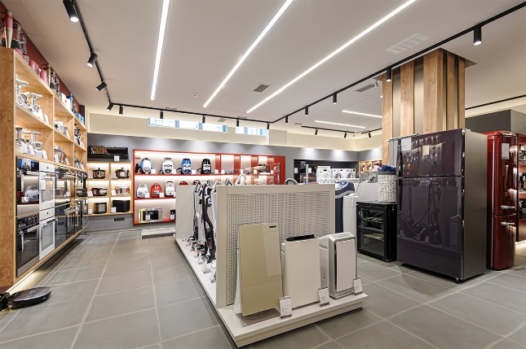

**Background:**

A Retail, a chain of supermarkets, aimed to enhance the shopping experience for customers while reducing operational costs. The company decided to install a smart lighting system in one of its flagship stores to improve energy efficiency, create a more appealing ambiance, and gather data on customer behaviour.

**Findings:**

**1 . Energy Efficiency:** The smart lighting system, equipped with motion sensors and daylight harvesting technology, reduced energy consumption by 30% compared to traditional lighting fixtures. Lights dimmed or turned off automatically in unoccupied aisles and areas with sufficient natural light.

**2. Enhanced Shopping Experience:** Customers responded positively to the improved lighting ambiance, which made the store more inviting and visually appealing. The ability to adjust lighting levels based on time of day and customer traffic improved comfort and visibility, leading to longer dwell times and increased sales.

**3. Data Insights:** The smart lighting system collected data on customer foot traffic patterns and dwell times in different sections of the store. Analysis of this data revealed peak shopping hours, popular product areas, and opportunities for layout optimization to maximize sales and improve customer flow.

**Recommendations:**

**1. Expand Implementation:** Roll out the smart lighting system to other stores in the chain to replicate energy savings and enhance customer experience across the retail network.

**2. Integrate with Analytics:** Integrate lighting data with existing customer analytics platforms to gain deeper insights into shopping behaviours and preferences, enabling targeted marketing strategies and store layout optimizations.

**3. Continuous Monitoring and Maintenance:** Implement regular monitoring and maintenance schedules to ensure optimal performance of the smart lighting system and address any issues promptly.

**CASE STUDY 2 :**

**Case Study 2:** Smart Lighting System Implementation in Office Building

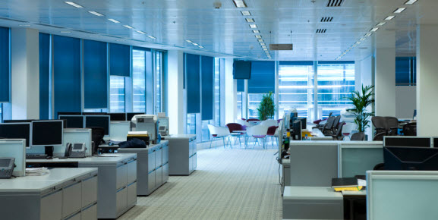

**Background:**

The Corporation, a multinational company, sought to create a modern, energy-efficient workspace for its employees. They implemented a smart lighting system in their office building to improve employee productivity, reduce energy costs, and contribute to sustainability goals.

**Findings:**

**1. Energy Savings:** The smart lighting system reduced energy consumption by 25% through features such as occupancy sensors, task-based lighting controls, and scheduling. Lights automatically adjusted brightness levels based on occupancy and time of day, minimizing wasted energy in unoccupied areas.

**2. Employee Productivity:** Employees reported higher levels of comfort and productivity with the implementation of the smart lighting system. Personalized lighting controls allowed individuals to adjust lighting levels according to their preferences, reducing eye strain and fatigue.

**3. Occupancy Insights:** Data collected from occupancy sensors provided valuable insights into workspace utilization patterns. XYZ Corporation used this data to optimize office layouts, allocate resources more efficiently, and implement flexible work policies based on actual usage patterns.

**Recommendations:**

**1. Employee Engagement:** Encourage employee feedback and involvement in fine-tuning lighting settings to meet individual preferences and work requirements.

**2. Expand Integration:** Integrate the smart lighting system with other building automation systems, such as HVAC and security, to create a more comprehensive and interconnected smart building environment.

**3. Educational Initiatives:** Provide training and educational resources to employees on the benefits of smart lighting and how to utilize its features effectively to enhance their work experience.

CASE STUDY 3 :

**Case Study 3:** Smart Lighting System Implementation in Municipality

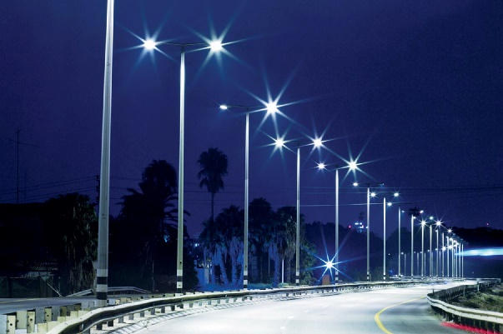

**Background:**

The City of Smart Ville aimed to modernize its infrastructure and improve energy efficiency as part of its sustainability initiatives. They implemented a city-wide smart lighting system to reduce energy consumption, enhance safety, and create a more attractive urban environment.

**Findings:**

**1. Energy Reduction:** The smart lighting system led to a 40% reduction in energy consumption across the city's streetlights through adaptive dimming, remote monitoring, and scheduling. Lights dimmed during low-traffic periods and brightened in response to pedestrian or vehicular activity, optimizing energy usage without compromising safety.

**2. Safety Improvements:** Residents and visitors felt safer walking and driving in well-lit streets with the implementation of the smart lighting system. Motion sensors detected movement in dimly lit areas, triggering lights to illuminate pathways and deter potential crime.

**3. Cost Savings:** The city saved significantly on maintenance costs and operational expenses due to the remote monitoring and predictive maintenance capabilities of the smart lighting system. Malfunctioning fixtures were identified and repaired promptly, reducing downtime and service interruptions.

**Recommendations:**

**1. Community Engagement:** Involve residents and local stakeholders in discussions about smart lighting initiatives to ensure alignment with community needs and preferences.

**2. Expand Smart Infrastructure:** Explore opportunities to expand the smart lighting system to include other municipal services, such as waste management, transportation, and public safety, to create a more integrated and efficient smart city ecosystem.

**3. Performance Monitoring:** Continuously monitor the performance of the smart lighting system and leverage data analytics to identify optimization opportunities and improve service delivery to residents and businesses.